**Week 3 – Notes**

**Object Localization**

There are 3 different tasks:

Image classification – predict what’s in the image (one object)

Classification with localization – predict what’s in the image and the bounding box coord (one object)

Detection – predict the classes and location of multiple objects in an image

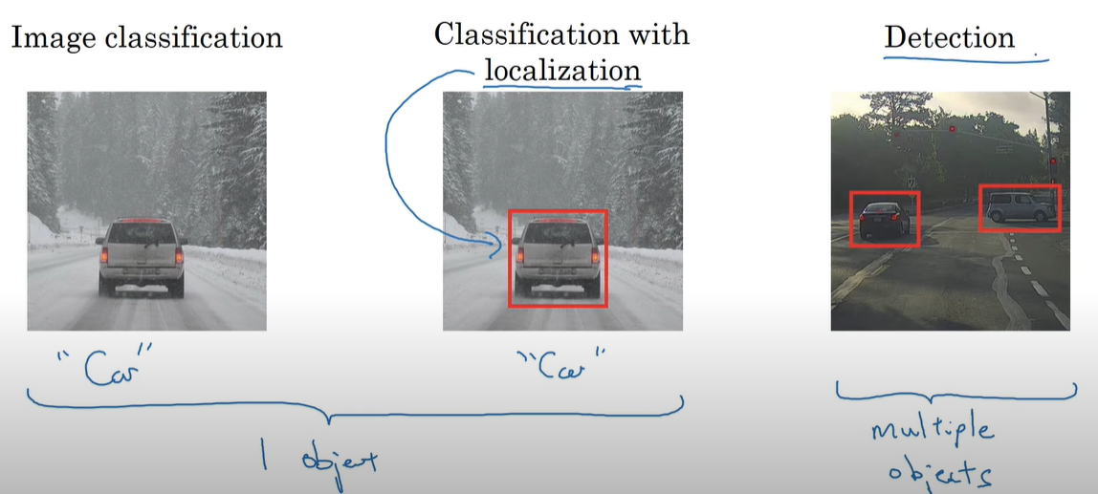

For classification with localization, your CNN predicts the class with a softmax function and also the coordinates of the bounding box (bx, by, bh, bw) where bx and by represent the center of the object and bw, bh the width and height of the image; in addition, the left top corner of the image has the coordinates 0,0 and the bottom right 1,1 so the annotated coordinates are in relation to these ones

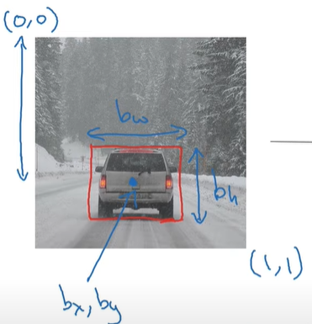

The CNN’s output is defined in the following way:

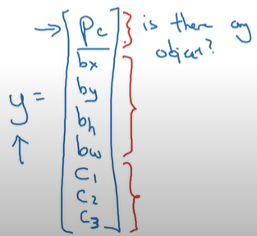

It’s important to have an output that specifies if we have or not an object of interest in the image because if we don’t, the loss isn’t computed on the rest of outputs (they are don’t care)

For the loss function, we can use:

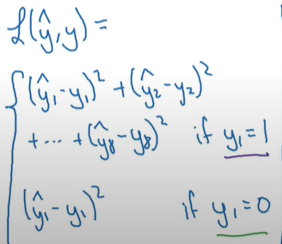, but in practice we use log likelihood loss for c1-3, square error for b and the logistic regression loss for pc

**Landmark Detection**

Exactly as you predict the bounding box of an object, exactly in the same way you can predict the position of landmarks (for example special points picked on the human face) + an output that predicts if a face is in the image or not

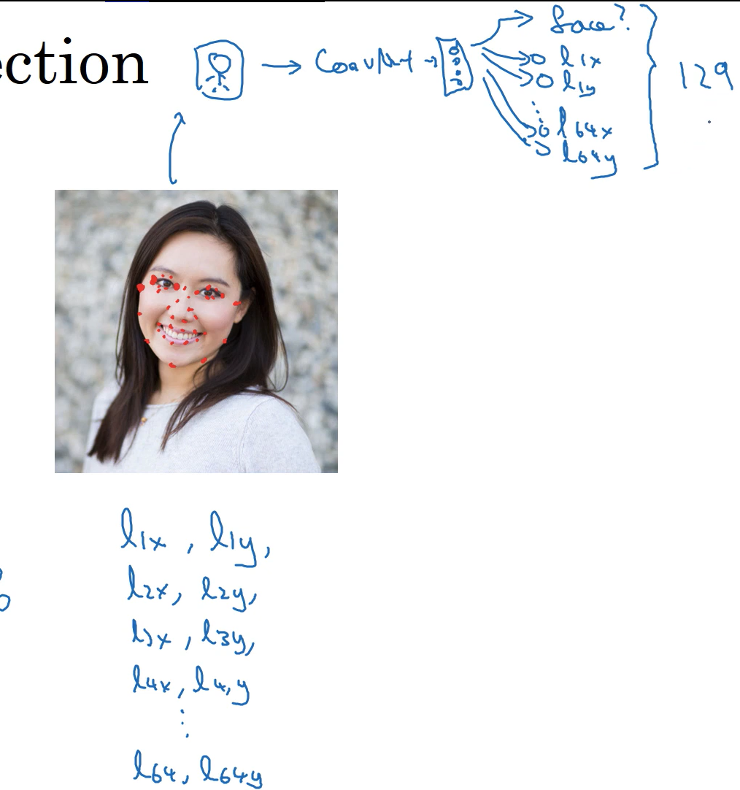

This landmark detector represents the baseline for snapchat filters (AR), sentiment detection and pose detection

It’s important to remain consistent across the labeled training set when placing landmarks

**Object Detection**

For this task we want to predict the class and bounding box of each object of interest from an image; the bounding boxes have to be placed so that they include as little as possible of the object surroundings

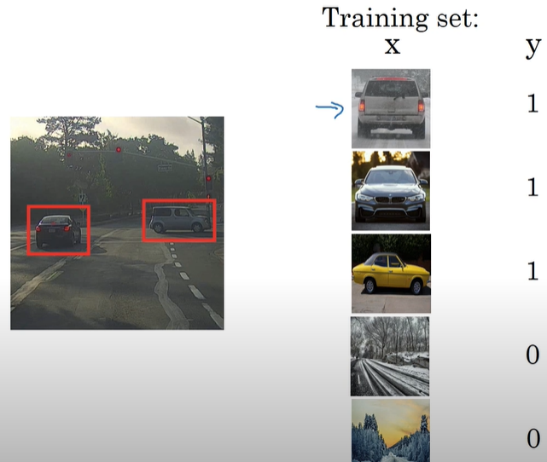

The most basic implementation is to create sliding windows of various sizes and to slide them on the image so that then you classify each region; this technique is called sliding windows detection

The problem is that the computational cost is extremely high but if you have a large stride (to reduce the number of classified regions) you can skip by mistake important image regions

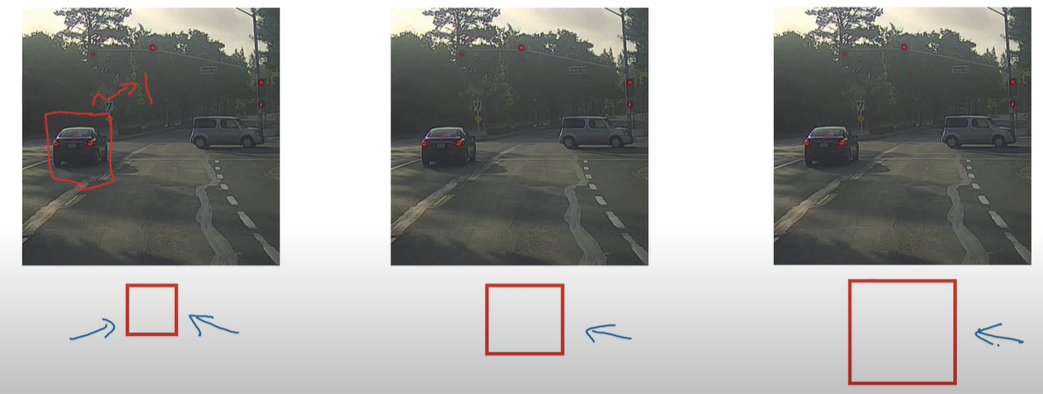

**Convolutional Implementation Sliding Windows**

A fully connected layer can be implemented with a convolutional layer

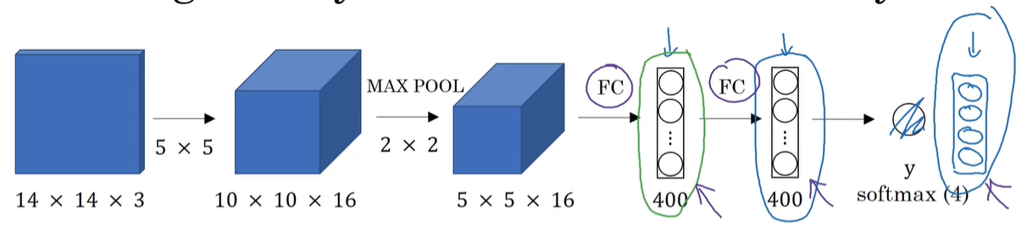

For example, in order to implement the first FC layer, we can use instead a CONV2D that has as many filters as the number of neurons in the FC layer (400 filters) of size as the previous layer (5x5x16)

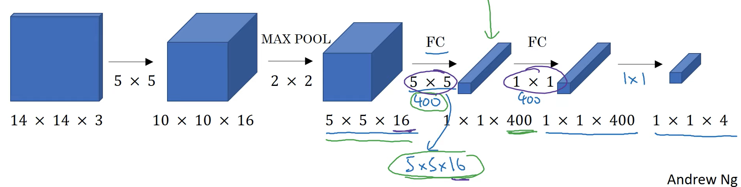

Instead of applying the whole CNN on each window, we can apply the CNN on the entire image because many input windows have common pixels and the extracted features can be shared

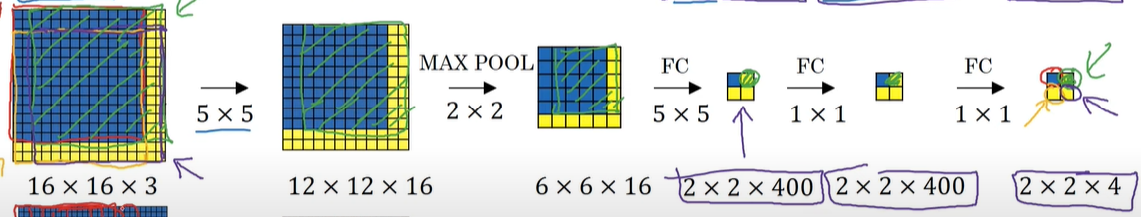

After applying the CNN on the whole image, each output position with its associated channels contains the predictions of the corresponding window

**Bounding Box Predictions**

The problem of the aforementioned implementation is that bounding boxes aren’t every time squared and, additionally, we can place, by design, the bounding box with a small offset

The YOLO algorithm, published in 2015, improves the convolutional implementation with sliding windows in the following way:

- each object is assigned to a window if its center falls inside it (one object only to one window)

- we take into consideration the bounding box of the object that will be predicted

- the coordinates of each object are represented with respect to its associated window

- to avoid windows that have multiple object centers inside them, we use a fine grid (e.g.: 19 x 19)

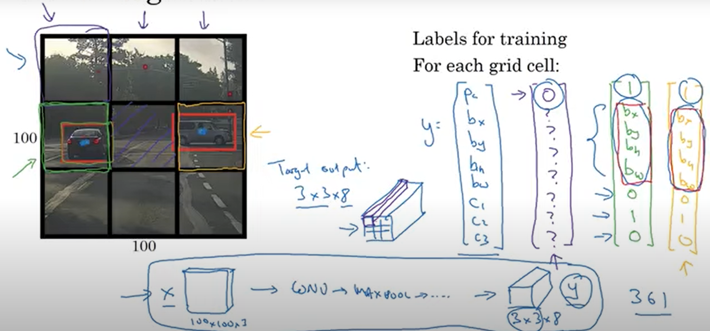

YOLO algorithm is really fast because it detects all objects and classifies them in one shot

Because bounding boxes are defined in relation to the associated window, bx and by are between 0 and 1, but bh and bw can be bigger than 1 considering that one object can span to many windows

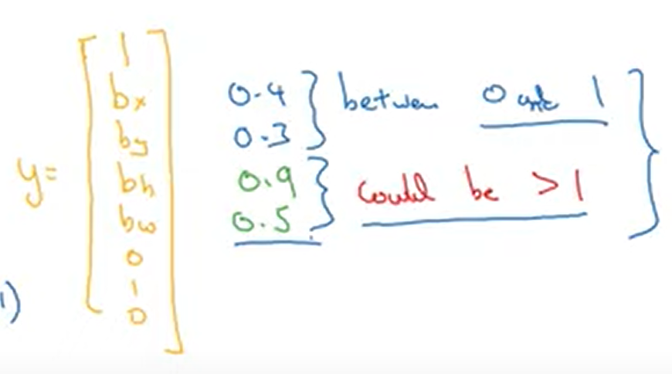

Each window has coordinates between 0 and 1

**Intersection Over Union**

In order to evaluate the object localization, we may want to compute the IoU, as the ration between intersection area of predicted bb and the ground truth bb and reunion of these 2 bb

In practice, the usual minimum accepted IoU is 0.5

However, many researchers use 0.6 or even 0.7 for more overlapping, but they don’t use values lower than 0.5

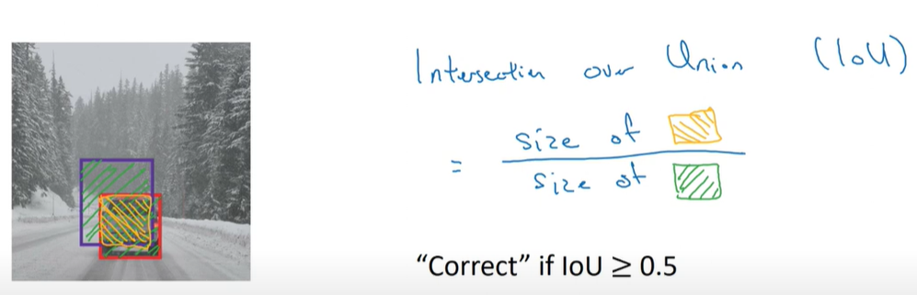

**Non-max Suppression**

We want a way to get rid of multiple predictions for the same object, so that we end up with the best estimated

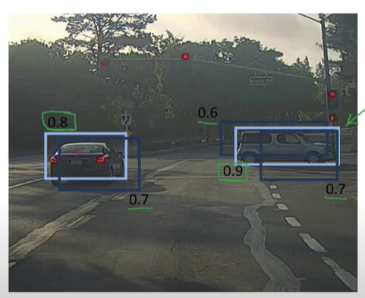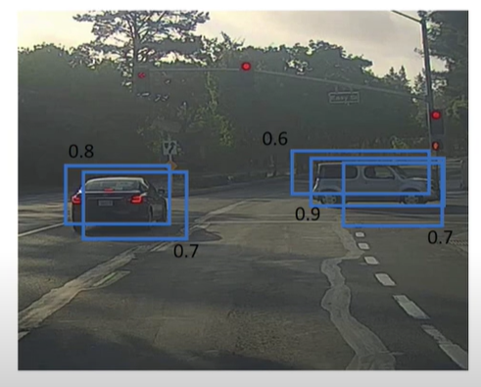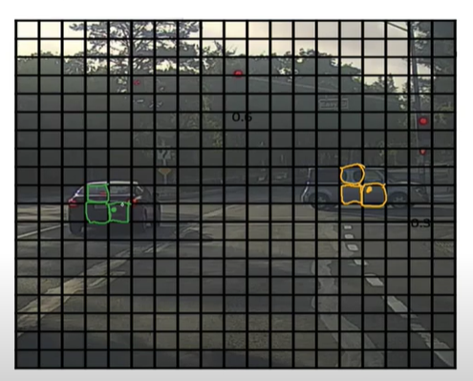

The non-max suppression algorithm can help us achieve that regardless of the number of objects present in the image

Algorithm:

discard all boxes with pc <= 0.6

while there are any remaining boxes:

pick the box with the largest pc and output it as a prediction

discard any remaining box with IoU >= 0.5 with the box output in the previous step